EASTERN MEDITERRANEAN UNIVERSITY

THE SCHOOL OF COMPUTING AND TECHNOLOGY

2023/2024 FALL/SPRING SEMESTER

ITEC404 GRADUATION PROJECT REPORT

INTERNSHIP MANAGEMENT SYSTEM

Prepared By

20910069 Dauda Fahad M Garba

18701661 Ahmad Ibrahim Bashanfar

20700091 Abdulhakim Sani Abbas

19700705 Omar Jain

**JUNE 2023.**

Table of Contents

1 Introduction 2

1.1 Project Scope and Objectives 3

1.2 Project Objectives and Requirements 4

2 Hardware and Software Requirements 4

1.3 2.1 Hardware Requirements 5

3 Existing Systems 6

3.2 Internshala: 6

4 Proposed System 7

1.4 Planned Activities 7

1.5 Issues and Risks 7

5 Project Management Plan and Gantt Chart 8

6 UML Modeling 12

1.6 General Use-Case Diagram 13

1.7 Partial Use-Case Diagram 13

1.8 Use-Case Templates 17

1.9 Activity Diagrams 36

1.10 Domain Class Diagram 53

1.11 Sequence Diagrams: 55

1.12 Package Diagram: 69

1.13 Database: 70

7 References 75

# Introduction

The Internship administration System is a comprehensive and user-friendly web-based tool that is aimed to revolutionize internship administration for educational institutions, employers, and students. With internships becoming increasingly important in bridging the gap between academic learning and real-world work experiences, there is a rising need for an effective and streamlined system to handle the numerous activities involved in managing internships. The Internship Management System strives to address these issues by providing a unified platform for all parties.

Internships have become an essential component of a student's educational path in today's competitive employment market. They provide essential opportunities to learn practical skills, network with industry professionals, and improve one's employability. However, the process of managing internships can be time-consuming and labor-intensive, involving responsibilities such as internship management posting, application submission and tracking, selection and monitoring, and evaluation. Manual processes and paperwork often lead to inefficiencies, miscommunications, and delays.

By providing a consolidated and automated solution, the Internship Management System intends to transform this process. Employers may quickly advertise internship jobs with details such as requirements, duration, and benefits. Students, on the other hand, can look for and apply for internships that match their interests and professional objectives. The solution allows businesses and students to communicate seamlessly, resulting in a smooth and transparent application process.

The Internship Management System provides significant administrative capabilities to educational institutions. Program coordinators and administrators can monitor and administer the whole internship program, track internship progress, and evaluate both student and employer performance. The system delivers useful insights and data that can be used to optimize the internship program, identify areas for improvement, and measure the overall effectiveness of the program.

## Project Scope and Objectives

The project's scope comprises the creation of a complete internship management system with a variety of functionality and features. Students will be able to submit internship applications, internship coordinators will be able to examine and confirm applications, and internship supervisors will be able to monitor and evaluate student performance. Furthermore, the system will provide document management, notifications, and reporting.

The following are the main goals of the Internship Management System:

* Simplify the internship application process for students by ensuring that all essential information is submitted accurately and efficiently.
* Simplify the internship confirmation process by allowing internship coordinators to assess and accept student applications.
* Make document management easier by allowing the uploading and verification of required internship documents including confirmation forms and social insurance forms.
* Allow students to submit daily logbooks detailing their efforts during the internship.
* Allow internship supervisors to analyze and provide feedback on student performance based on logbook entries.
* Assist students in submitting final reports and allowing the departmental internship coordinator to evaluate them.
* Provide bilingual help (English and Turkish) to accommodate a broad user base.

## Project Objectives and Requirements

The Internship Management System encompasses a set of instructions and minimum requirements to fulfill its intended functionalities. These instructions are outlined below:

* + 1. **Internship Application Form**

1. Students must complete and submit an internship application form.
2. Duration options of 20 (partial) or 40 (full) working days should be provided.
   * 1. **Application Confirmation**
3. The departmental internship coordinator can confirm, refuse, or delete the application.
4. Upon confirmation, an account is created for the internship supervisor from the company.
   * 1. **Internship Confirmation Form**
5. The internship supervisor completes and prints the Internship Confirmation Form.
6. The form is signed, stamped, scanned, and uploaded to the system by the internship supervisor.
   * 1. **Social Insurance Form**
7. If the internship is in TRNC or Turkey, students must complete the Social Insurance Form.
8. Three copies of the form, along with identity card/passport copies and bank receipt, are submitted to the departmental internship coordinator.
9. No insurance form is required for internships in other countries.
   * 1. **Document Verification and Logbook Submission**
10. The departmental internship coordinator verifies the uploaded documents.
11. Once the officially stamped and uploaded confirmation form (Step 3) and social insurance form (if applicable, Step 4) are confirmed, students gain access to submit daily logbook entries.
    * 1. **Internship Evaluation**
12. At the end of the internship period, the internship supervisor evaluates the student's performance based on the logbook details.
13. The evaluation result is confirmed or refused by the departmental internship coordinator.

# Hardware and Software Requirements

## 2.1 Hardware Requirements

* + 1. **Server:** A dedicated server or cloud hosting service capable of running web applications.
    2. **Processor:** Multi-core processor (e.g., Intel Core i5 or equivalent) for optimal performance.
    3. **RAM:** Minimum 8 GB RAM to handle simultaneous user requests and database operations.
    4. **Storage:** Sufficient storage space to store the application files, database, and uploaded documents.
    5. **Network:** Stable internet connection with sufficient bandwidth to support concurrent user access.

**2.2** Software Requirements

* + 1. **Operating System:** Linux (e.g., Ubuntu, CentOS) or Windows Server operating system.
    2. **Web Server:** Apache or Nginx web server for hosting the application.
    3. **Database Management System:** MySQL or PostgreSQL for data storage and retrieval.
    4. **Programming Languages:**

1. **Front-End:** HTML, CSS, JavaScript (with frameworks like React or Angular).
2. **Back-End:** Node.js or PHP (with frameworks like Express or Laravel).
   * 1. **Version Control:** Git for source code management and collaboration.
     2. **Security:** SSL certificate for secure data transmission (HTTPS).
     3. **Email Service:** SMTP server configuration for sending notification emails.
     4. **Text Editor/IDE:** Visual Studio Code, Sublime Text, or any preferred text editor for code development.
     5. **Additional Libraries and Frameworks:** Depending on the chosen programming languages and frameworks, additional libraries and frameworks may be required for specific functionalities (e.g., file uploads, form validation).

**2.3** Browser Compatibility

The Internship Management System should be compatible with commonly used web browsers such as Google Chrome, Mozilla Firefox, Safari, and Microsoft Edge. Ensure proper testing and compatibility for different browser versions.

**2.4** Security Considerations

Implement necessary security measures to protect user data, including secure login/authentication, encrypted data transmission (HTTPS), input validation, and protection against common web vulnerabilities (e.g., cross-site scripting, SQL injection).

# Existing Systems

* 1. Internshala:Internshala is a popular online platform that connects students with internship opportunities. It offers a comprehensive internship management system where students can apply for internships, track their application status, and manage their internship profiles. Employers can post internships, review applications, and communicate with interns through the platform.
  2. Simplicant:Simplicant is a cloud-based talent acquisition and applicant tracking system that includes internship management features. It allows organizations to create and manage internship programs, post internship openings, receive and review applications, and communicate with interns. It also provides reporting and analytics capabilities for tracking intern performance.
  3. Intertrack:Intertrack is an internship management system specifically designed for educational institutions. It helps colleges and universities streamline their internship programs by providing features such as internship posting, student application management, document management, evaluation tracking, and reporting
* **State of the art**

Mobile Compatibility: The system should have a responsive design and mobile application support, allowing students, employers, and coordinators to access and manage internship-related tasks on their mobile devices.

Integration with Learning Management Systems (LMS): Integrating the internship management system with existing LMS platforms allows students to seamlessly access internship-related resources, submit assignments or reports, and receive feedback from supervisors and coordinators.

Integration with Social Media Platforms: Social media integration can enable easy sharing of internship opportunities, networking among students and employers, and promoting successful internships, enhancing visibility and engagement.

Automated Reminders and Notifications: The system can send automated reminders and notifications to students and employers for upcoming deadlines, document submissions, evaluation periods, and other important milestones, ensuring timely and efficient communication.

Gamification Elements: Incorporating gamification elements like badges, achievements, and progress tracking can motivate students to actively engage in their internships, complete tasks, and showcase their skills.

Integration with Career Services: Integrating the internship management system with career services platforms can facilitate seamless transitions from internships to full-time employment, providing students with additional support in their career development journey.

# Proposed System

Managing internships can be a daunting task for universities, students, and companies. Therefore, the development of an effective Internship Management System is highly imperative to streamline the process and provide a comprehensive tool for coordination between all the parties involved.

Our web-based internship management system will be built to overcome all the difficulties facing the current paper-based Internship Management System. With the help of this system, we aim to tackle and eliminate some of these issues e.g., lack of flexibility, slow transmission of information etc.

Additionally, this software will be developed to meet all the needs of the parties involved in the internship program, which include the departmental internship coordinators, company internship supervisors, and students to conduct the training program seamlessly and efficiently.

This software will be providing an Internship Application form which aims to simplify the application process. These applications will then be reviewed and accepted/rejected/deleted on the system.

## Planned Activities

During our initial phase, we distributed our responsibilities among the members of the group. On each iteration, we meet and link all the work that was done. The main goal was to develop a workable online test system that would match our client's requirements.

First, substantial study was conducted when the minimum requirements were assigned to our group, which can be found in Appendix A1. We investigated many different existing systems, what they lacked, and attempted to construct an improved proposed system using all of the ideas and expertise we gathered. Our first step was to research the business needs that were provided to us, then use the knowledge we gathered to build our vision, specify the scope, and track our estimates for our group's timelines and milestones.

## Issues and Risks

Issues arose right from the start of the inception phase and lasted throughout the requirements phase, where we had difficulties in assuming the project's vision and user requirements that were incomplete and changing as the project progressed. Some of the objectives were unclear, and I had to ask about them more than once.

Other concerns we had were the depth of our needs, defining the technology we wanted to use, and determining whether or not the new system integration would be simple. During our phases, we faced both internal and external hazards. Meeting deadlines and increasing effort due to only four members working on this project were two of our project concerns. Another issue we countered at first. There was user interaction from both the instructor and the students. These technical hazards might have jeopardized the quality and timeliness of our proposed system.

The addition of a subject property to our system, i.e. each chapter will contain themes, was not included in our use case because it was thought of later in the project. As previously said, user needs may vary, however they will be modified and included later as a simple tweak to the project.

One of our main issues was managing the database. Because we are working with sensitive information, duplicated data could damage our system. Combating these dangers and challenges will need significant work but will result in a more stable approach to the following phases.

# Project Management Plan and Gantt Chart

**Project Overview:**

The Internship Management System project aims to develop a comprehensive web-based application that facilitates the management of internships within an organization. The system will provide a centralized platform for internship coordination, application management, communication, and reporting.

**Project Objectives:**

Develop a user-friendly web-based application for managing internships.

Streamline the internship application and selection process.

Improve communication between internship coordinators, supervisors, and interns.

Provide reporting and analytics features for tracking and evaluating internship programs.

Enhance overall efficiency and effectiveness of internship management.

**Scope:**

The project will involve the following key activities:

Requirement gathering and analysis.

System design and architecture.

Application development and testing.

Integration with existing systems (if applicable).

User training and documentation.

Deployment and system maintenance.

**Project Deliverables:**

Requirements document

System design and architecture

Developed web application

User documentation

Training materials

Deployment plan

Maintenance and support plan

**Project Milestones:**

Milestone 1: Requirements gathering and analysis (Duration: 2 weeks)

Milestone 2: System design and architecture (Duration: 3 weeks)

Milestone 3: Application development and testing (Duration: 6 weeks)

Milestone 4: User training and documentation (Duration: 1 week)

Milestone 5: Deployment and system maintenance (Duration: Ongoing)

**Project Team:**

The project team will consist of the following roles:

Project Manager

Business Analyst

UI/UX Designer

Developers

Testers

Database Administrator

Technical Writers

Project Risks:

Lack of clarity in requirements.

Inadequate resources or skillset within the project team.

Technical challenges during application development.

Integration issues with existing systems (if applicable).

User adoption and resistance to change.

**Communication Plan:**

Regular project meetings will be held to discuss progress, address issues, and make decisions. Communication channels such as email, instant messaging, and project management tools will be used to ensure effective communication among team members.

**Quality Assurance:**

Quality assurance activities will be conducted throughout the project lifecycle to ensure that the developed application meets the specified requirements. Testing, code reviews, and user acceptance testing will be performed to validate the system's functionality, usability, and performance.

**Project Budget:**

A detailed project budget will be prepared, outlining the costs associated with resources, hardware, software, licenses, and any other project-related expenses. The budget will be regularly monitored and reviewed to ensure cost control.

**Project Stakeholders:**

Project Sponsor

Project Manager

Business Analyst

Development Team

Testing Team

Internship Coordinators

Supervisors

Interns

**Project Approval:**

This project plan requires the approval of the Project Sponsor and other relevant stakeholders before execution. Any changes to the plan will be managed through the established change control process.

By adhering to this Project Management Plan, the Internship Management System project aims to successfully deliver a robust and user-friendly application that enhances the management of internships within the organization.

# UML Modeling

## General Use-Case Diagram

## Partial Use-Case Diagram

* + 1. **STUDENT**

* + 1. **Company Supervisor**

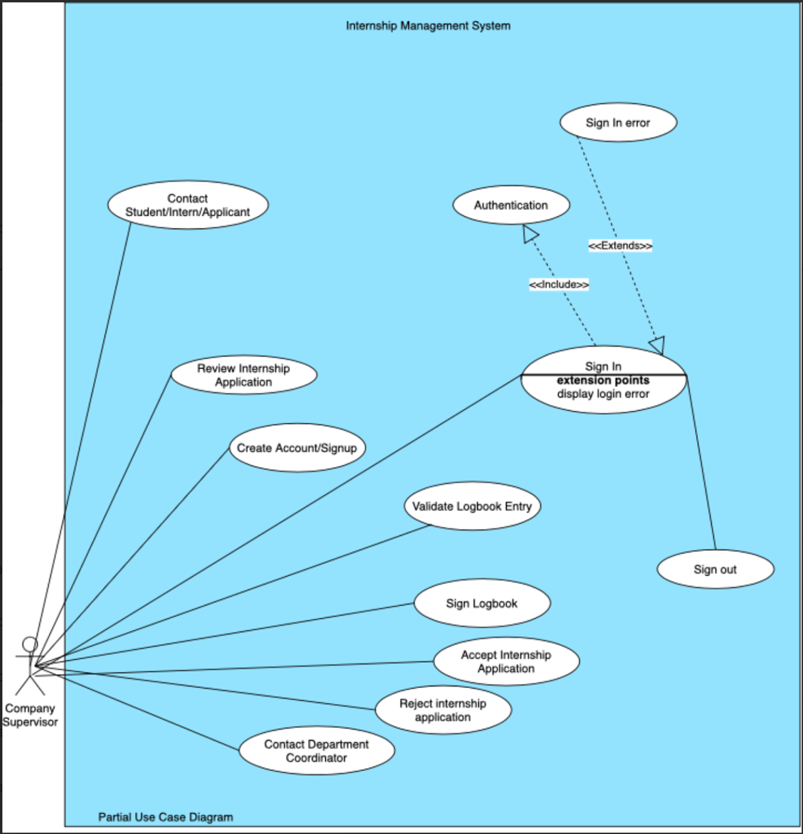

* + 1. **Department Coordinator**

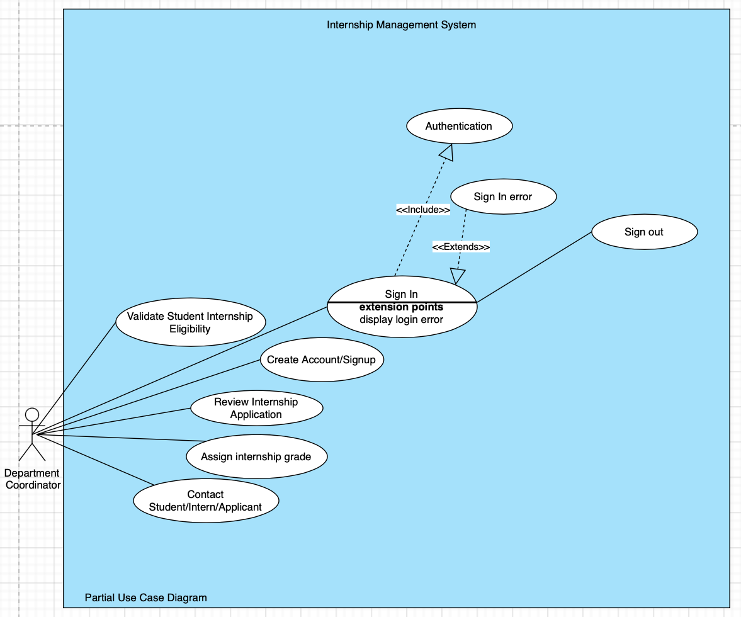

* + 1. **ADMIN**

## Use-Case Templates

1. **Sign In**

|  |  |  |
| --- | --- | --- |
| **Use Case Name** | Sign In | |
| **Scenario** | To sign into user account. | |
| **Triggering Event** | Request to Sign In | |
| **Brief Description** | To access the system’s features through a user account by providing login details. | |
| **Actors** | Student, Internship Supervisor, Department Internship Coordinator, Admin | |
| **Related Use Cases** | <<include>> Authentication | |
| **Stakeholders** |  | |
| **Preconditions** | 1. The user must be registered on the system. | |
| **Post conditions** | The user will be signed into the system, having access to the system’s features like main menu, dashboard, user profile etc. | |
| **Flow of events** | **ACTOR** | **SYSTEM** |
| 1. The user requests to sign in. 2. User enters sign in credentials. | * 1. Displays the sign in form.   2. Validates user sign in credentials.   3. Grant user access to the user account. |
| **Exception Conditions** | 2.1 If the sign in credentials is invalid/incorrect, display “Login error message”. | |

1. **Sign-up**

|  |  |  |
| --- | --- | --- |
| **Use Case Name** | Sign Up | |
| **Scenario** | To create a new user account. | |
| **Triggering Event** | User requests to Sign Up | |
| **Brief Description** | To create a new user account in order to be able to access the system’s features. | |
| **Actors** | Student, Internship Supervisor, Department Internship Coordinator | |
| **Related Use Cases** | <<include>> Authentication | |
| **Stakeholders** |  | |
| **Preconditions** | 1. The user must be either a student/staff of EMU or a company offering internship. | |
| **Post conditions** | A user account will be created in accordance with the information provided by the user. | |
| **Flow of events** | **ACTOR** | **SYSTEM** |
| 1. The user clicks on sign-up/create account. 2. The user fills the form and submits it to the system. | * 1. Displays the sign-up/create account form.   2. The system validates form data.   3. The system creates a new account and saves user data under the account. |
| **Exception Conditions** | 2.1 If any data provided in the sign-up form is invalid, the system prompts the user to re-enter. | |

1. **Manage User Profile**

|  |  |  |
| --- | --- | --- |
| **Use Case Name** | **Manage User Profile** | |
| **Scenario** | To manage user profile i.e., view, edit, or delete user profile data. | |
| **Triggering Event** | User requests to display profile on the user interface. | |
| **Brief Description** | To view, and possibly modify initially provided user account data. | |
| **Actors** | **Student, Supervisor, Coordinator, Admin** | |
| **Related Use Case** |  | |
| **Stakeholders** |  | |
| **Preconditions** | 1. User must have an existing registered account on the system. | |
| **Postconditions** | System displays user profile data on the user interface allowing the user to modify this data. | |
| **Flow of events** | **ACTOR** | **SYSTEM** |
| 1. User requests to display profile on the user interface. | 1.1 System displays user account dashboard with user profile data. |
| **Exception Conditions** |  | |

1. **Internship Search**

|  |  |  |
| --- | --- | --- |
| **Use Case Name** | **Internship Search** | |
| **Scenario** | To search for available internship programs. | |
| **Triggering Event** | User enters a search keyword in the search input. | |
| **Brief Description** | To search and view available internship programs on the system. | |
| **Actors** | **Student, Supervisor, Coordinator, Admin** | |
| **Related Use Case** |  | |
| **Stakeholders** |  | |
| **Preconditions** | 1. User must have an existing registered account on the system. | |
| **Postconditions** | System displays all available internships that match search keyword on the user interface. | |
| **Flow of events** | **ACTOR** | **SYSTEM** |
| 1. User enters a search keyword in the search input. | 1.1 System displays all available internships that match search keyword. |
| **Exception Conditions** |  | |

1. **Add Internship**

|  |  |  |
| --- | --- | --- |
| **Use Case Name** | **Add Internship** | |
| **Scenario** | To add new internship programs to the system’s database. | |
| **Triggering Event** | User clicks ‘Add Internship’ | |
| **Brief Description** | To add new internship programs to the system’s database to display the program to users. | |
| **Actors** | **Company Supervisor, Coordinator, Admin** | |
| **Related Use Case** | **<<include>> Authentication** | |
| **Stakeholders** |  | |
| **Preconditions** | 1. User must have an existing registered account on the system.  2. User must have a supervisor, coordinator, or admin user account type. | |
| **Postconditions** | System saves to database and then displays the newly added internship program. | |
| **Flow of events** | **ACTOR** | **SYSTEM** |
| 1. User clicks ‘Add Internship’.  2. User enters internship program information | 1.1 System displays ‘add internship form’.  2.1 System verifies and validates form data.  2.2 System saves newly added internship to its database.  2.3 System displays newly added internship on its user interface. |
| **Exception Conditions** | 2.1 If any data provided on the form is not valid, System returns appropriate error message. | |

1. **Review Application**

|  |  |  |
| --- | --- | --- |
| **Use Case Name** | Review Application | |
| **Scenario** | To review an internship application submitted by a student. | |
| **Triggering Event** | User clicks on a specific internship application. | |
| **Brief Description** | The user requests the review a submitted internship application. | |
| **Actors** | Department Internship Coordinator, Company Supervisor | |
| **Related Use Cases** |  | |
| **Stakeholders** |  | |
| **Preconditions** | 1. User must have a supervisor or coordinator account. 2. A filled and submitted internship application must exist. | |
| **Post conditions** | The system displays the details of a submitted internship application for review. | |
| **Flow of events** | **ACTOR** | **SYSTEM** |
| 1. User clicks on a specific internship application. | 1.1 The system displays details of a submitted internship application for review. |
| **Exception Conditions** |  | |

1. **Submit Application**

|  |  |  |
| --- | --- | --- |
| **Use Case Name** | Submit Application | |
| **Scenario** | To submit an internship application. | |
| **Triggering Event** | User requests to create a new internship application | |
| **Brief Description** | The user creates and submits an internship application by providing all required information. | |
| **Actors** | Student | |
| **Related Use Cases** |  | |
| **Stakeholders** |  | |
| **Preconditions** | 1. User must be a student of EMU. 2. User must have an account registered on the system. | |
| **Post conditions** | The submitted application is sent to the appropriate parties to decide (Accept/Reject) regarding the user’s application. | |
| **Flow of events** | **ACTOR** | **SYSTEM** |
| 1. The user requests to create a new internship application. 2. The user fills and submits application form. | * 1. The system displays the requirements & application form.   2. The system validates form data.   3. The system saves application and sends a confirmation to the user. |
| **Exception Conditions** | 2.1 If any data provided in the form is incorrect/invalid, the system prompts the user to enter valid data. | |

1. **View Logbook**

|  |  |  |
| --- | --- | --- |
| **Use Case Name** | **View Logbook** | |
| **Scenario** | To open and view internship logbook. | |
| **Triggering Event** | User clicks ‘Internship Logbook’ | |
| **Brief Description** | To open and view internship logbook. | |
| **Actors** | **Student, Supervisor, Coordinator, Admin** | |
| **Related Use Case** | **<<include>> Authentication** | |
| **Stakeholders** |  | |
| **Preconditions** | 1. User must have an existing registered account on the system.  2. User must be signed in. | |
| **Postconditions** | System displays internship logbook on its user interface. | |
| **Flow of events** | **ACTOR** | **SYSTEM** |
| 1. User clicks ‘Internship Logbook’. | 1.1 System displays ‘internship logbook’. |
| **Exception Conditions** |  | |

1. **Document Manager**

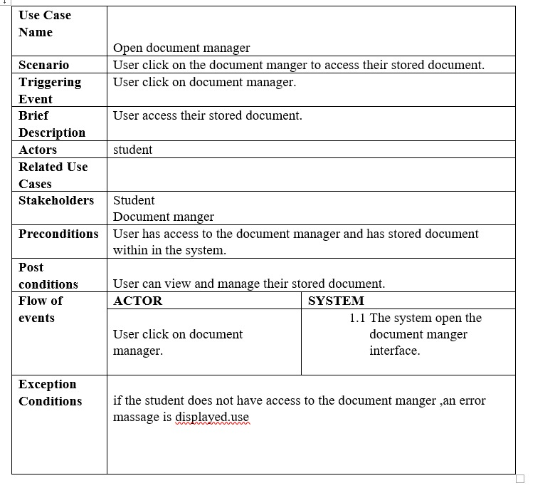

1. **Resource Library**

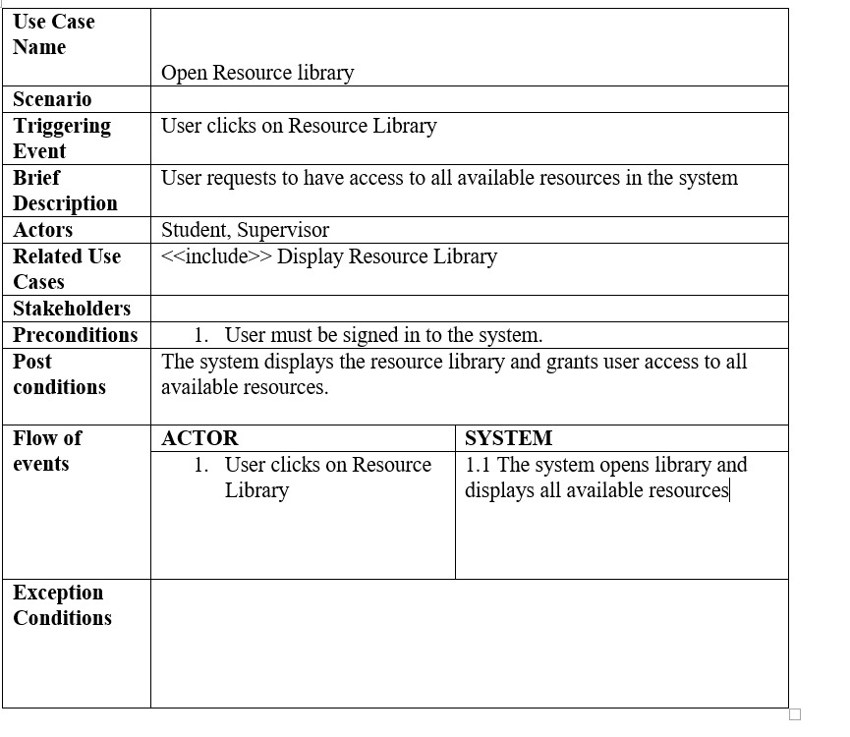

1. **Progress Tracker**

|  |  |  |
| --- | --- | --- |
| **Use Case Name** | **Progress Tracker** | |
| **Scenario** | To open and view internship progress tracker. | |
| **Triggering Event** | User clicks ‘Progress Tracker’ | |
| **Brief Description** | To open and view internship progress tracker. | |
| **Actors** | **Student, Supervisor, Coordinator, Admin** | |
| **Related Use Case** | **<<include>> Authentication** | |
| **Stakeholders** |  | |
| **Preconditions** | 1. User must have an existing registered account on the system.  2. User must be signed in. | |
| **Postconditions** | System displays internship progress tracker, information about how much work has been covered so far and is yet to be covered. | |
| **Flow of events** | **ACTOR** | **SYSTEM** |
| 1. User clicks ‘Progress Tracker’. | 1.1 System displays ‘Progress Tracker’. |
| **Exception Conditions** |  | |

1. **View Internship**

1. **Upload Resume**

1. **Contact Supervisor**

1. **Contact Coordinator**

1. **FAQ Internships**

1. **Reset Password**

|  |  |  |
| --- | --- | --- |
| **Use Case Name** | Reset Password | |
| **Scenario** | To change existing user account password. | |
| **Triggering Event** | User requests to Reset Password | |
| **Brief Description** | To replace existing user account password with a new password. | |
| **Actors** | Student, Internship Supervisor, Department Internship Coordinator | |
| **Related Use Cases** | <<include>> Authentication | |
| **Stakeholders** |  | |
| **Preconditions** | 1. The user must have a valid existing account registered on the system. | |
| **Post conditions** | A user account password will be changed to the most recently provided password by the user. | |
| **Flow of events** | **ACTOR** | **SYSTEM** |
| 1. The user clicks on reset password. 2. The user fills the form and submits it to the system. | * 1. The system displays the password reset form.   2. The system validates new password to see if it matches existing password.   3. The system saves the new password in the database. |
| **Exception Conditions** | 2.1 If the new password matches the existing password, the system prompts the user to provide a new password that does not match existing password. | |

1. **Change Password**

|  |  |  |
| --- | --- | --- |
| **Use Case Name** | Change Password | |
| **Scenario** | To change existing user account password. | |
| **Triggering Event** | User requests to Change Password | |
| **Brief Description** | To replace existing user account password with a new password. | |
| **Actors** | Student, Internship Supervisor, Department Internship Coordinator, Admin | |
| **Related Use Cases** | <<include>> Authentication | |
| **Stakeholders** |  | |
| **Preconditions** | 1. The user must have a valid existing account registered on the system. | |
| **Post conditions** | A user account password will be changed to the most recently provided password by the user. | |
| **Flow of events** | **ACTOR** | **SYSTEM** |
| 1. The user clicks on reset password.   1. The user fills the form and submits it to the system. | * 1. The system displays the password reset form.   2. The system validates new password to see if it matches existing password.   3. The system saves the new password in the database. |
| **Exception Conditions** | 2.1 If the new password matches the existing password, the system prompts the user to provide a new password that does not match existing password. | |

1. **Sign Out**

|  |  |  |
| --- | --- | --- |
| **Use Case Name** | **Sign Out** | |
| **Scenario** | To log user out of user account. | |
| **Triggering Event** | User clicks ‘Sign Out’ | |
| **Brief Description** | To sign out of user account. | |
| **Actors** | **Student, Supervisor, Coordinator, Admin** | |
| **Related Use Case** | **<<include>> Authentication** | |
| **Stakeholders** |  | |
| **Preconditions** | 1. User must have an existing registered account on the system.  2. User must be signed in. | |
| **Postconditions** | System displays internship progress tracker, information about how much work has been covered so far and is yet to be covered. | |
| **Flow of events** | **ACTOR** | **SYSTEM** |
| 1. User clicks ‘Sign Out’. | 1.1 System logs user out of user account. |
| **Exception Conditions** |  | |

## Activity Diagrams

* + 1. **Sign-in**

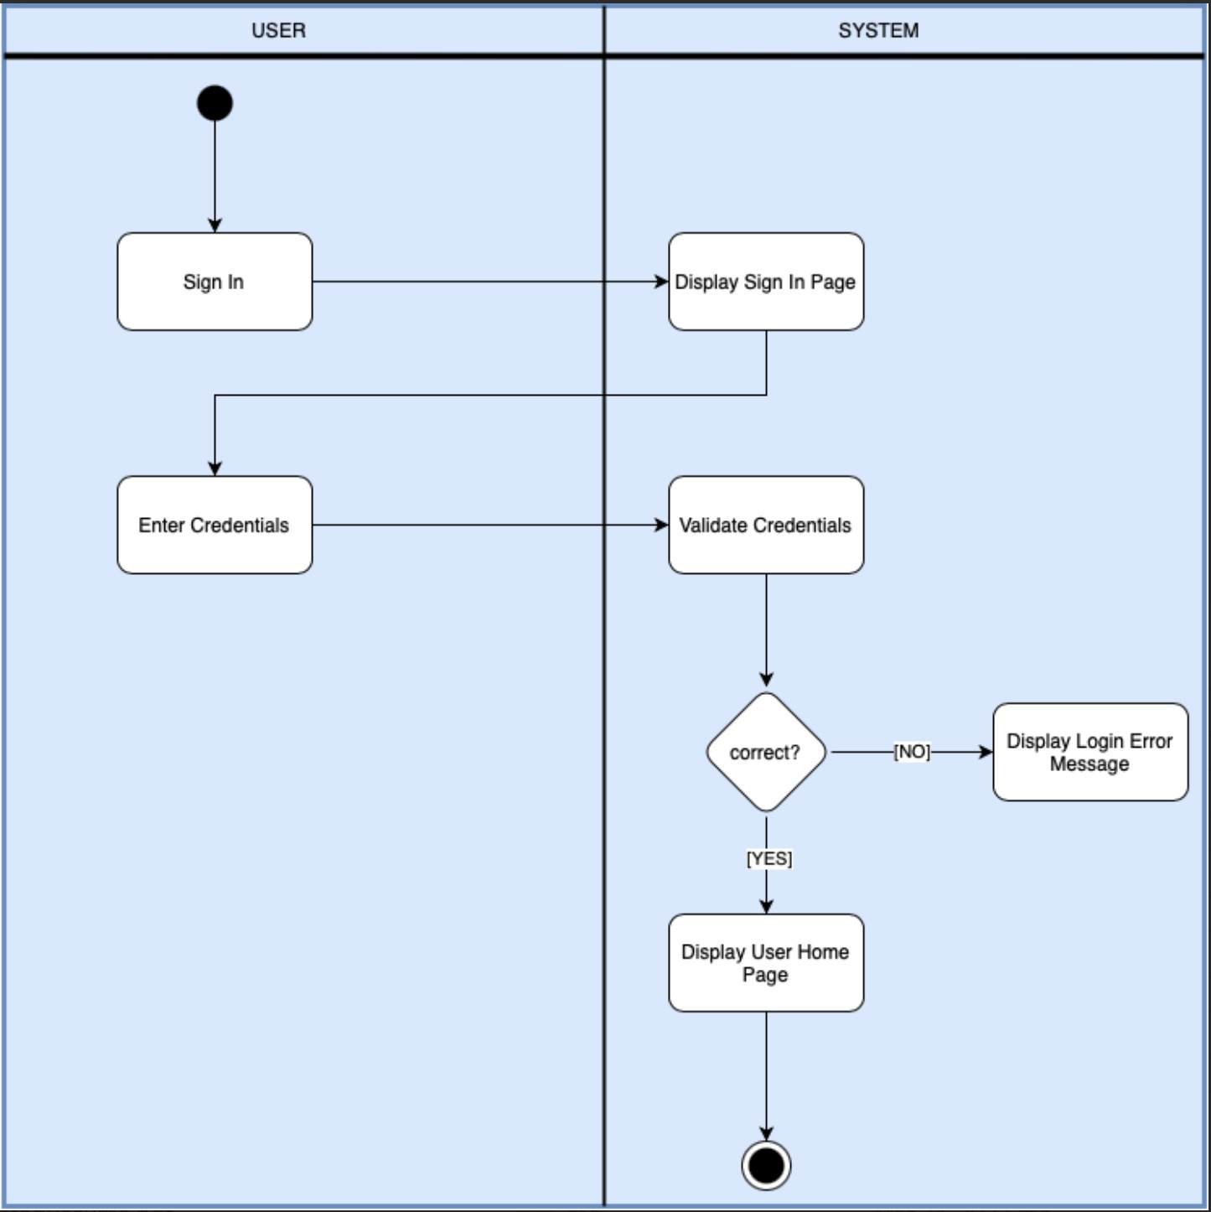

* + 1. **Sign-up**

* + 1. **Manage Profile**

* + 1. **Internship Search**

* + 1. **Add Internship**

* + 1. **View Internship Program**

* + 1. **Review Application**

* + 1. **Submit Internship Application**

* + 1. **View Logbook**

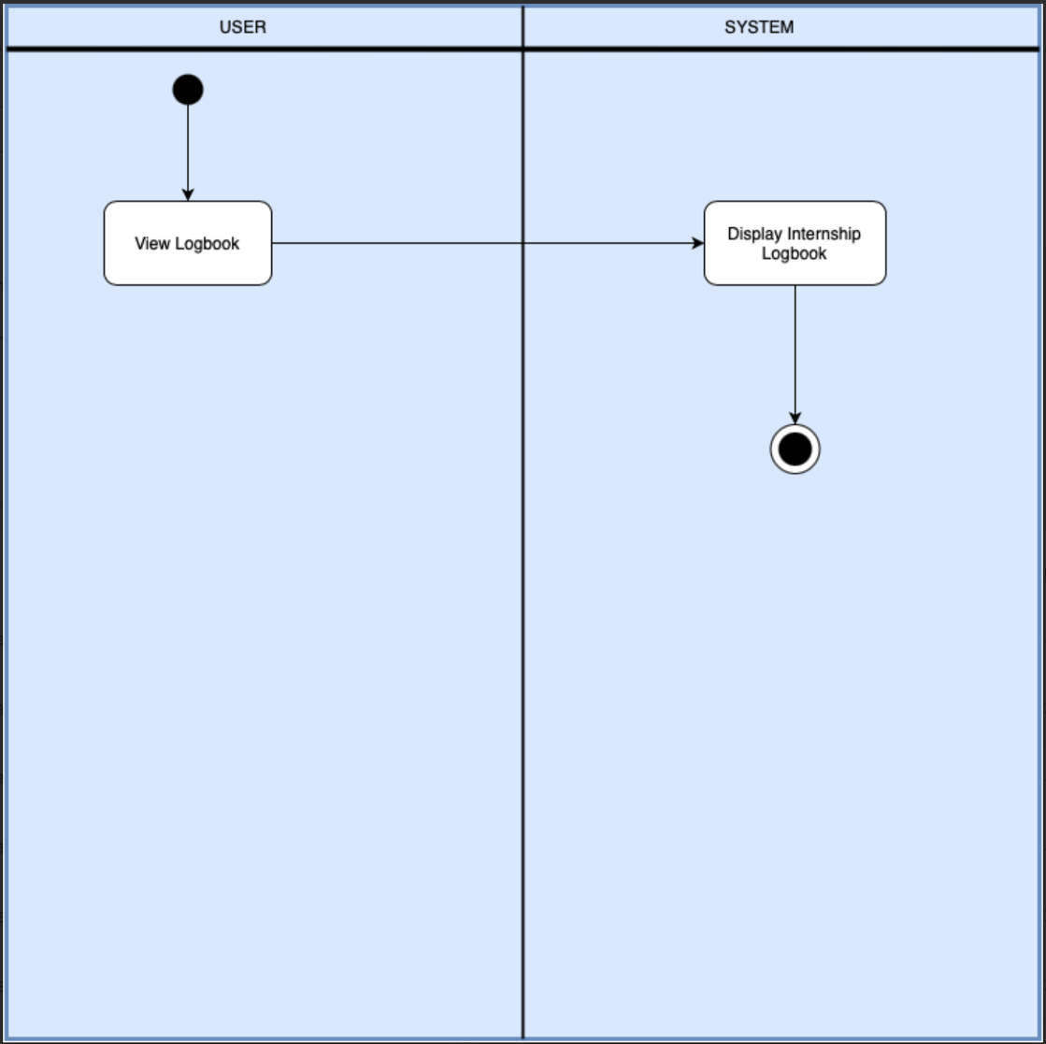

* + 1. **Document Manager**

* + 1. **Resource Library**

* + 1. **Progress Tracker**

* + 1. **View Internship**
    2. **Upload Resume**

* + 1. **Contact Company Supervisor**

* + 1. **Contact Coordinator**

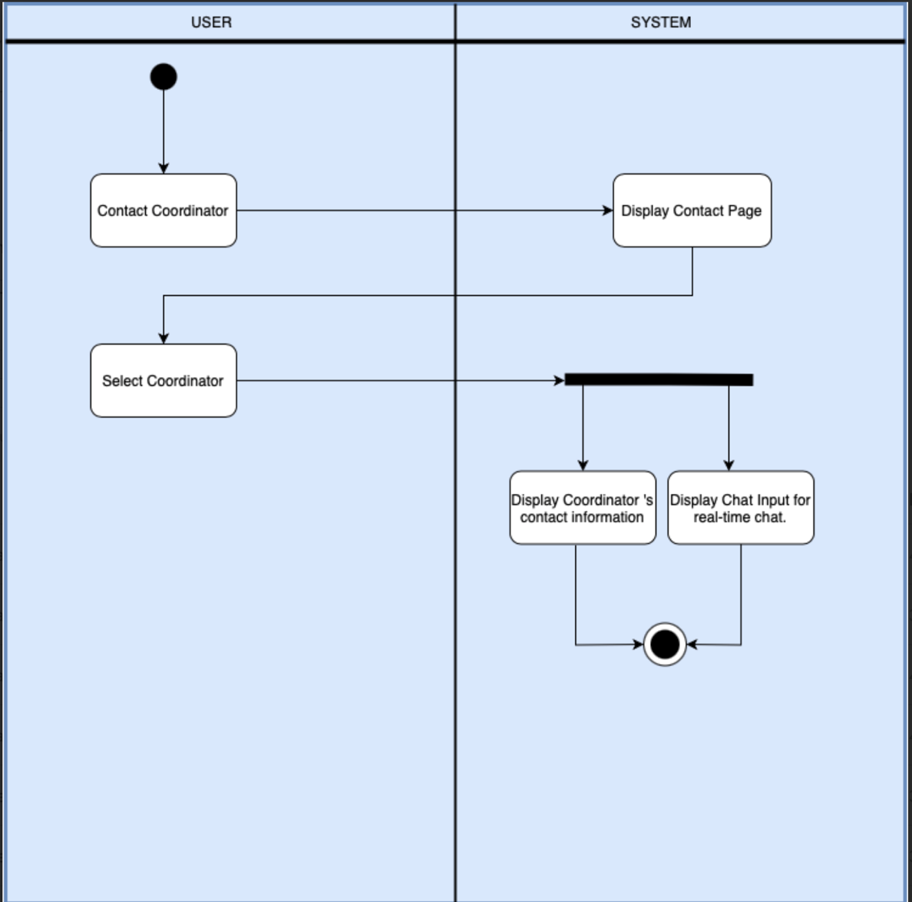

* + 1. **FAQ Internships**

* + 1. **Reset Password**

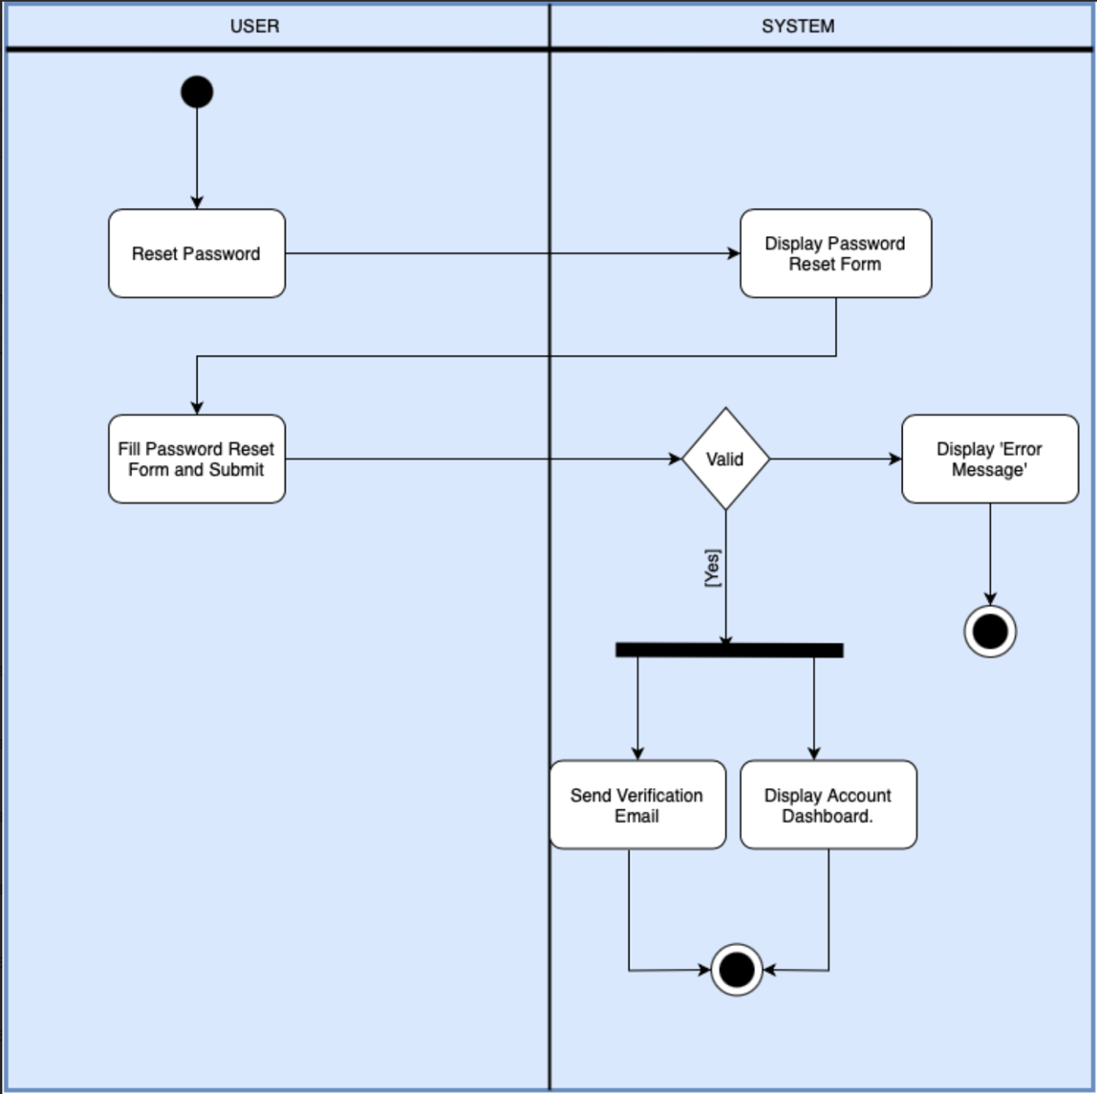

* + 1. **Change Password**

* + 1. **Sign Out**

## Domain Class Diagram

## Sequence Diagrams:

Accept Or Reject Application:

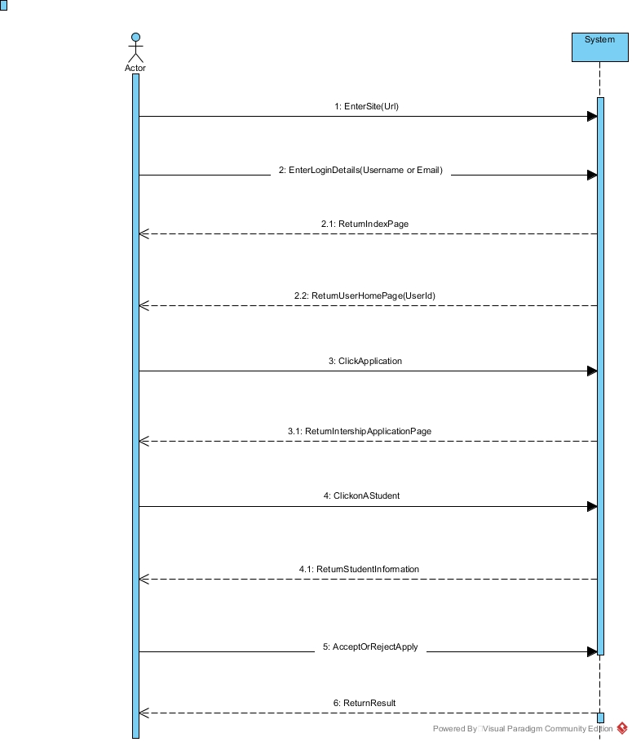

Add Internship:

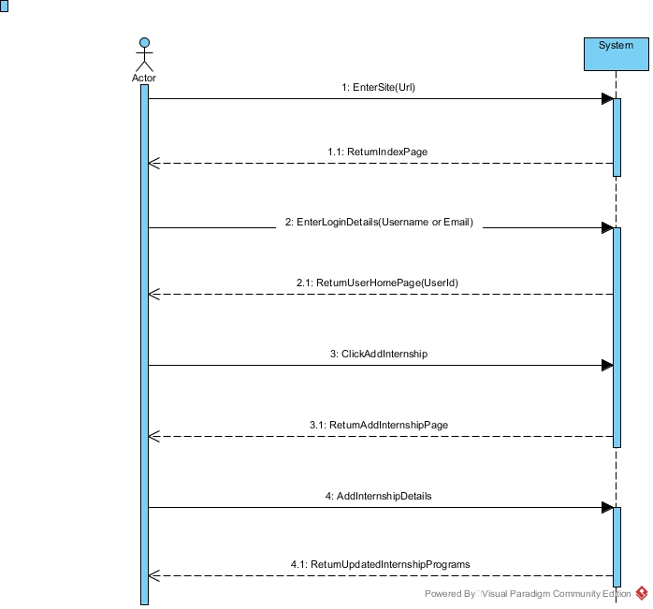

Apply Internship:

# 

Contact Coordinator:

# 

Contact supervisor:

# 

Intern Progress:

# 

Login:

# 

Manage Profile:

# 

Register:

# 

Review Internship:

# 

Search Internship:

# 

Upload Logbook:

# 

Upload Resume:

# 

## Package Diagram:

# 

## Database:

**ENTITY TYPE DOCUMENT:**

|  |  |  |  |
| --- | --- | --- | --- |
| **ENTITY NAME** | **DESCRIPTION** | **ALIASES** | **OCCURENCES** |
| STUDENT | Students of the department. | std |  |
| PROFILE | A summary of a person's qualifications, skills, and background. |  |  |
| COORDINATOR | A person responsible for organizing and managing internship. | Professor |  |
| SUPERVISOR | Someone who oversees and guides the work of the intern. | Employer |  |
| DEPARTMENT | An organizational unit within the institution with specific functions. |  |  |
| COMPANY | Business Institution looking for Intern |  |  |
| REPORT | Documentation about the internship. |  |  |
| INTERNSHIP | A temporary work experience providing practical training. |  |  |
| ANNOUNCEMENT | A formal statement conveying important information or news. |  |  |

**Relationship Type Document:**

|  |  |  |  |
| --- | --- | --- | --- |
| **Relationship Type** | **Entity Type** | **Cardinality Ratio** | **Participation** |
| has | Student | 1 | Mandatory |
| Profile | 1 | Mandatory |
| make | Coordinator | 1 | Mandatory |
| Announcement | M | Optional |
| Approve/Reject | Coordinator | 1 | Mandatory |
| Application | M | Optional |
| create | Student | 1 | Mandatory |
| Account | M | Optional |
| make | Student | M | mandatory |
| Report | M | Optional |
| supervise | Supervisor | M | mandatory |
| Student | M | mandatory |

**Attribute Document:**

|  |  |  |  |  |  |  |  |  |
| --- | --- | --- | --- | --- | --- | --- | --- | --- |
| **Entity/Relationship Type** | **Attribute** | **Description** | **Data Type and Length** | **Constraint** | **Default Value** | **Alias** | **Null?** | **Derived?** |
| STUDENT | StudentID | Unique identifier for students | Varchar2(10) |  |  | std | NO |  |
| FirstName | First name of the student | Varchar(30) |  |  |  |  |  |
| LastName | Last name of the student | Varchar(30) |  |  |  |  |  |
| Email | Student's email address | Varchar(30) |  |  |  |  |  |
| Address | Student's address | Varchar(50) |  |  |  |  |  |
| DateOfBirth | Date of Birth | Date |  |  |  |  |  |
| PROFILE | ProfileID | Unique identifier for profiles | Varchar2(10) | PK |  |  | NO |  |
| StudentID | Identifier linking to a student | Varchar2(10) | FK |  |  | NO |  |
| ProfileText | Text description of the profile | Varchar(255) |  |  |  |  |  |
| COORDINATOR | CoordinatorID | Curriculum unique no | Varchar2(10) | PK |  |  | NO |  |
| FirstName | Curriculum Program | Varchar(30) |  |  |  |  |  |
| LastName | Semester course offers | Varchar(30) |  |  |  |  |  |
| Email | Coordinator's email address | Varchar(30) |  |  |  |  |  |
| SUPERVISOR | SupervisorID | Unique identifier for supervisors | Varchar2(10) | PK |  |  | NO |  |
| FirstName | First name of the supervisor | Varchar(30) |  |  |  |  |  |
| LastName | Last name of the supervisor | Varchar(30) |  |  |  |  |  |
| Email | Supervisor's email address | Varchar(30) |  |  |  |  |  |
| DEPARTMENT | DepartmentID | Unique identifier for departments | Varchar2(10) |  |  |  | NO |  |
| DepartmentName | Name of the department | Varchar(30) |  |  |  |  |  |
| COMPANY | CompanyID | Unique identifier for companies | Varchar2(10) | PK |  |  | NO |  |
| CompanyName | Name of the company | Varchar(30) |  |  |  |  |  |
| Location | Company's location | Varchar(30) |  |  |  |  |  |
| REPORT | ReportID | Unique identifier for reports | Varchar2(10) | PK |  |  | NO |  |
| StudentID | Identifier linking to a student | Varchar2(10) | FK |  |  | NO |  |
| ReportDate | Date of the report | Date |  |  |  |  |  |
|  | Content | Text content of the report | text |  |  |  |  |  |
| INTERNSHIP | InternshipID | Integer Unique identifier for internships | Varchar2(10) | PK |  |  | NO |  |
| CompanyID | Identifier linking to a company | Varchar2(10) | FK |  |  | NO |  |
| StudentID | Identifier linking to a student | Varchar2(10) | FK |  |  | NO |  |
| StartDate | Start date of the internship | Date |  |  |  |  |  |
| EndDate | End date of the internship | Date |  |  |  |  |  |
| ANNOUNCEMENT | AnnouncementID | Unique identifier for announcements | Varchar2(10) | PK |  |  | NO |  |
| AnnouncementText | Text of the announcement | text |  |  |  |  |  |
| AnnouncementDate | Date of the announcement | Date |  |  |  |  |  |

# References

* [**https://scholarworks.lib.csusb.edu/cgi/viewcontent.cgi?article=3592&context=etd-project**](https://scholarworks.lib.csusb.edu/cgi/viewcontent.cgi?article=3592&context=etd-project)
* [**https://www.internship4students.com**](https://www.internship4students.com)
* [**https://internshala.com**](https://internshala.com)
* [**https://iopscience.iop.org/article/10.1088/1757-899X/662/2/022090/pdf**](https://iopscience.iop.org/article/10.1088/1757-899X/662/2/022090/pdf)
* [**https://iopscience.iop.org/article/10.1088/1757-899X/662/2/022090/pdf**](https://iopscience.iop.org/article/10.1088/1757-899X/662/2/022090/pdf)
* [**https://www.youtube.com/watch?v=VBzl-1QT1fs**](https://www.youtube.com/watch?v=VBzl-1QT1fs)